UI

For the UI part of this model, we have used the gradio library in python.

Gradio is the fastest way to demo your machine learning model with a friendly web interface

Interface is Gradio's main high-level class, and allows you to create a web-based GUI / demo around a machine learning model (or any Python function) in a few lines of code. You must specify three parameters: (1) the function to create a GUI for (2) the desired input components and (3) the desired output components. Additional parameters can be used to control the appearance and behaviour of the demo.

To use gradio in our system we use the command of :-

*Import gradio as gr*

Class method that constructs an Interface from a Hugging Face transformers. Pipeline object. The input and output components are automatically determined from the pipeline.

Here are some snapshots of the UI of the model :-

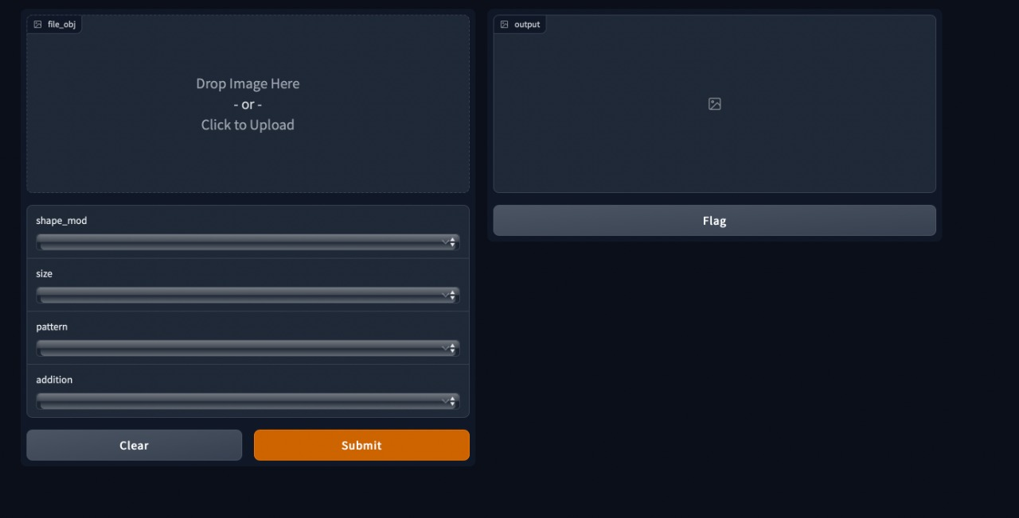

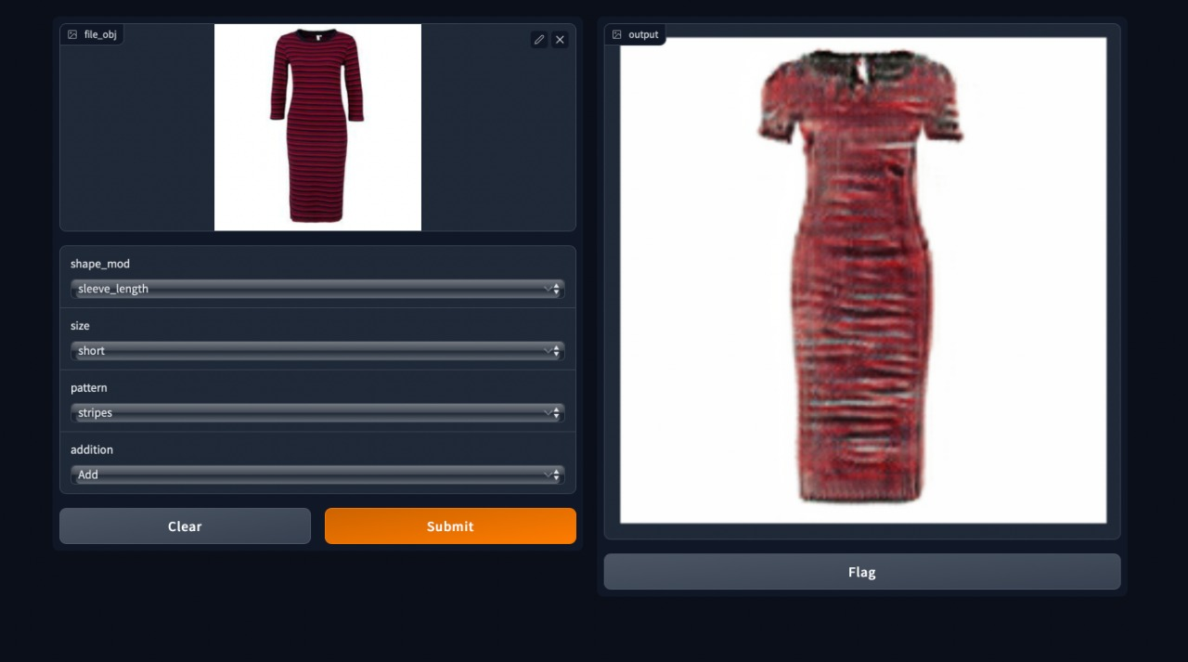

The online fashion industry has seen a huge spike in consumers since the pandemic hit the world in 2020. From large brands to small start-ups, the trend of online shopping gained massive popularity. This resulted in designers pushing their limits to produce large amounts of new designs in an incredibly quick time. To tackle this strain, FashionGAN has been introduced. It is a generative adversarial network that produces customised dress designs based on user input. FashionGAN app works on a GAN modifier and searches for products and models. It provides a newly generated image based on users’ inputs. It includes features to modify dress size, patterns, sleeve lengths, etc. The scope is to generate base designs for dresses, so that designers only need to work on refinements and details.

The online fashion industry has seen a huge spike in consumers since pandemic hit the world in 2020. . From large brands to small start-ups, the trend of online shopping gained massive popularity. This resulted in designers pushing their limits to produce large amounts of new designs in an incredibly quick time. To tackle this strain, FashionGAN has been introduced. It is a generative adversarial network that produces customised dress designs based on user input

As mentioned in the introductory slide – during the pandemic the Fashion industry gained a massive popularity which resulted in designers have all the work strain. To tackle this problem we created FashionGAN. It is a generative adversarial network that produces customised dress designs based on user input. FashionGAN app works on a GAN modifier and searches for products and models. It provides a newly generated image based on users’ inputs. It includes features to modify dress size, patterns, sleeve lengths, etc. The scope is to generate base designs for dresses, so that designers only need to work on refinements and details.